README: Replicating Steve’s ATLAS environment
Initial Capture History and release definition
- go to "paired release" study design
- Click "Load Capture Histories"
  - Load detection histories prepped in TagPro: “COMB_REL_lrg_hanf_pooled_ATLAS.csv”
- In Define release group. Choose these options for Chinook
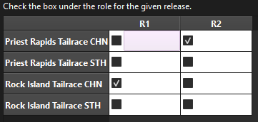
- go to " Select Downstream Sites” and you should see the following
- “Required” appears on hover
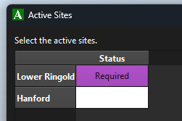
- Go to “View Mixing”
  - Add 74 as offset for Chinook (76 for Steelhead)
    - Toggle “Detection_Site” or click “Done” and reopen to update
  - Should see:
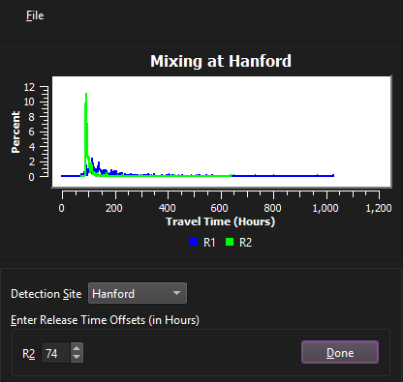
Setup Tag Life Model
- Adding taglife information
  - Go to “Load Tag Life Data”
    - Select file called “Pooled_taglife.csv”
  - Go to “Fit Tag Life Curves”
    - Selected loaded data set
    - Select Weibull 2-paamter
    - Censor 68 tags
    - Click Apply
  - Click Calculate Tag Life Corrections
Report and Plot Creation
- Double click “Generate Reports”
  - Set output directory
  - Click “Create Reports”
- Should produce these files:
- 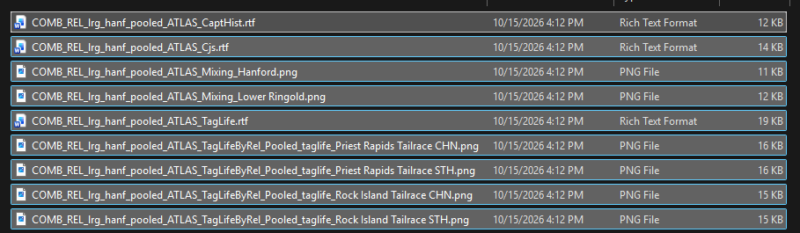

- Go to Pooled taglife Weibull 2 with 68 censored tags



